**Salon SURALIYA Web Application**

Diploma in Software Engineering

Final Project Documentation

2020.2F



**SCHOOL OF COMPUTING AND ENGINEERING**

**NATIONAL INSTITUTE OF BUSINESS MANAGEMENT**

**KURUNEGALA**

i

**Title of the project:** Web Application for Salon SURALIYA

**Authors:** KUDSE202F-019 M.Sandani Vihara Madampage

KUDSE202F-015 G.P.D.Gunawardhana

KUDSE202F -025 B.K.S.Udeshika Senanayake

**Name of the program:** Diploma in Software Engineering

**Name of supervisor:** Mrs. P.E.N.Perera

**Name of institution:** School of computing and engineering,

National Institute of Business Management

**Date of the declaration:** 31-05-2022

**The project is submitted in partial fulfillment of the requirement of the Diploma of Computer System Design of National Institute of Business Management.**

ii

**DECLARATION.**

I certify that this project does not incorporate without acknowledgement, any material previously submitted for a Diploma in any institution and to the best of my knowledge and belief ,it does not contain any material previously published or written by another person or myself except where due reference is made in the text. I also hereby give consent for my project report, if accepted, to be made available for photocopying and for interlibrary loans, and for the title and summary to be made available to outside organizations.

DSE 20.2F Batch

1. M.Sandani Vihara Madampage KUDSE202F-019 ……………………..
2. G.P.D.Gunawardhana KUDSE202F-015 ……………………..
3. B.K.S.Udeshika Senanayake KUDSE202F-025 ……………………..

Certified by:

………………………………… …………………………………

Project Supervisor Date

(Mrs. P.E.N.Perera)

iii

**CONTENTS**

1. Abstract ……………………………………………………………….

2. List of keywords………………………………………………………

3. List of figures …………………………………………………………

4. List of tables …………………………………………………………..

5. List of acronyms and abbreviations …………………………………..

6. Acknowledgement …………………………………………………….

7. Chapter 1: Introduction ………………………………………………..

7.1. Introduction of the Organization …………………………….

7.2. Organization Structure ………………………………………

7.3. Current Operations in Organization …………………………

7.4. Users and Responsibilities Organization …………………….

7.5. Problem Definition ………………………………………….

7.6. Project Objectives …………………………………………...

7.7. Proposed Solution …………………………………………...

7.8. Chapter Summery ……………………………………………

8. Chapter 2: Methodology ……………………………………………….

8.1. Introduction ………………………………………………….

8.2. Data Collection Method(s) …………………………………..

8.3. System Development Methodology…………………………

iv

8.4. Software Development Tools ………………………………..

8.5. Testing Strategies ……………………………………………

8.6. Implementation Plan …………………………………………

9. Chapter 3: Analysis ………………………………………………………

9.1. Introduction ………………………………………………………

9.2. DFD Diagrams ……………………………………………………

9.2.1. Context Level Diagram of Proposed System ……………

9.2.2. Level 0 DFD Diagram of Proposed System ……………

9.2.3. Level 1 DFD Diagram of Proposed System ……………

9.3. UML Diagram ……………………………………………………

9.3.1. Use Case Diagram of Proposed System ……………...

9.3.2. Class Diagram of Proposed System ………………….

9.3.3. ER Diagram of the Proposed System ………………...

9.4. Chapter Summery …………………………………………………

10. Chapter 4: Solution Design ……………………………………………….

10.1. Introduction ………………………………………………………

10.2. Interface Design ………………………………………………….

11. Chapter 5: Conclusion …………………………………………………….

12. References …………………………………………………………………

v

13. Appendices ………………………………………………………………...

13.1. The project Schedule ……………………………………………...

13.2. Letter Issued by the organization …………………………………

13.3. Questioners and Interview Questions …………………………….

13.4. Reviewed Documents …………………………………………….

14. User Manual Documentation …….............................................................

14.1. Chapter 1 – Introduction ………………………………………….

14.2. Chapter 2 – How to install the system ……………………………

14.2.1. Minimum requirements ………………………………………

14.2.2. Installation …………………………………………………..

14.2.3. How to install the system by using CD ROM ……………….

14.3. Chapter 3 – Login to the system …………………………………

14.4. Chapter 4 – Operations and functions ……………………………

14.4.1. Home Page ……………………………………………..

14.4.2. About Page …………….……………………………

14.4.3. Services Page ……………………………………………

14.4.4. Gallery Page …………………………………………

14.4.5. Contact Page …………………………………………..

14.4.6. Book Now Page …………………………………………..

vi

**ABSTRACT**

Salon Suraliya is a well-recognized and reputed salons among peoples around the Gonagama area. Day by day their customer base is growing up. Therefore hard to maintain salon internal process. Issuing reliable report is much needed, Because of these salon owner willing to manage their salons from one place and also to keep their well reputation among salons and peoples much needed.

They have no automation system for their process. Even if they use computers and tablet they do not have proper system to full fill their needs. They are using small paper cards to tracking their services. This is very inefficient and unreliable. And keeping records not accurate with relevant salon data when calculate reports.

This system will provide the functionalities of manage salons’ details, manage day by day bookings, manage service, manage notification system for day to day transactions. This system will help to improve the higher efficiency in the processes in the salons. It will enable salon staff to add data to the system without bothering about creating report formats that will increase the efficiency of salon staff. In this case salon’s confidential data will not be available to the unauthorized access.

The web development project was implemented using notepad++ as the IDE and SQL server used as the DBMS. In addition, Visual Paradigm for UML was used to draw the UML diagrams shown in this interim report.

The system will provide user friendly simple interface which will help them to make reliable, quick and effective service to their customers.

vii

**List of keywords**

* Interface
* HTML
* CSS
* MYSQL
* Computer-based program
* Computerized system
* Spiral model
* Notepad++
* Unit testing
* System testing
* Performance testing
* Pilot program
* Onboarding and training
* Diagrams

viii

**List of figures**

Figure 1: Image of Salon

Figure 2: Product Satisfaction Survey by Salon Owner

Figure 3: Product Satisfaction Survey by Customer

Figure 4: Summary of Product Satisfaction Survey

Figure 5: Context level diagram of proposed system

Figure 6: Level 0 DFD diagram of proposed system

Figure 7: Level 1 DFD Diagram for 1.0 Process (Booking Schedule)

Figure 8: Level 1 DFD Diagram for 1.0 Process (Staff Details)

Figure 9: Level 1 DFD Diagram for 1.0 Process (Services Details)

Figure 10: Level 1 DFD Diagram for 1.0 Process (Latest News Details)

Figure 11: Use Case Diagram

Figure 12: Class Diagram

Figure 13: ER Diagram

Figure 14: Letter Issued by the organization

Figure 15: Letter Issued by the organization for satisfaction

**List of tables**

Table 1: Development Tools

Table 2: Interface Design

Table 3: Project timeline

ix

**List of acronyms and abbreviations**

* SS – Salon Suraliya
* RAM - Random Access Memory
* HDD - Hard disk drive
* Gb - Gigabyte
* RAD - Rapid Application Development
* OOAD - Object Oriented Analysis and Designing
* DBMS - Database Management System
* UML - Unified Modeling Language
* DFD – Data Flow Diagram
* ER - Entity-Relationship
* CSS - Cascading Style Sheets
* CLR - Common Language Runtime
* EF - Entity Framework
* MVC - Model–View–Controller pattern
* XAML - Extensible Application Markup Language
* HTML – Hyper Text Markup Language
* SQL - Structured Query Language

x

**Acknowledgement**

We are extremely grateful and remain indebted to our course director **Mrs. P.E.N.Perera** and our consultant/lecturer **Mr.Tharanga Ekanayake**, for being a source of inspiration and those constant supports in the guiding, designing and Evaluation of the project.

We are thankful to them for their constant constructive criticism and invaluable suggestions, which benefited us a lot while developing the project on “**Web Application for Salon Suraliya.**”

Our sincere appreciation goes to the Salon Suraliya owner Sewwandi Madumadavi and staff, who enlightened me about the processes and functionalities of the salon and co-operated in the course of development of the project.

We are also grateful to our families and friends especially to our parents for support given in every way possible throughout the process of this diploma program through one year.

xi

**CHAPTER 1: INTRODUCTION**

* 1. **Introduction of the Organization**

Day by day modern beauty culture is getting rapidly popular among the peoples, specially among young men and woman. Also they are having a habit of preferring a usual one beautician. So the salon owners are eager to provide their services at its best to the customers for make sure they are remain with salon as long as. In this case they are looking for best way to manage their salons in more efficiencies and keep customers attractive to salons.

SALON SURALIYA is a well-recognized and reputed salon located in Gonagama. Address of SALON SURALIYA is Kubhukgate Road, Gonagama, Sri Lanka. SALON SURALIYA can be contacted at +9476 3242016. SALON SURALIYA is located in a busy area, with at least 1500 listed places around it.

When we consider about the business it is a Small and Medium scale salon that provides multiple type of services like hair beauty treatments for Eyes, Facial, Nail care, Home made Cakes and also Bridal service.

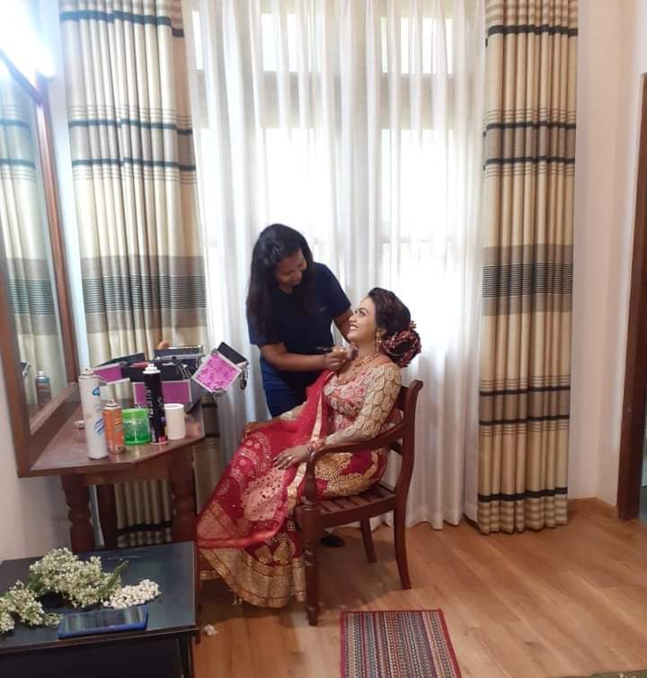

***Figure 1: Image of Salon***

1

* 1. **Organization Structure**

This organization has a managing director in top of the management in this organization and then trainers, beautician staff and also customers are also has some roles in this organization.

Managing director

customers

Beautician staff

Trainers

**1.3. Current Operations in Organization**

There are few operations in this organization,

• Issue bills

• Issue schedules

• Trainer work schedules issue and prepare

• Issue cleaning schedules

• Manage members practice card and schedule

• Create members admission documents

2

**1.4. Users and Responsibilities Organization**

• Managing director – Overall management of the organization

• Trainers – Train/practice members

• Cashier – Make payments and Issue bills in organization

• Cleaning staff - Clean/Arrange organization

• Customers – taking the service

**1.5. Problem Definition**

The Bull Fitness Gym is facing some problems in their management and business process as following,

* Salon Suraliya Palace is well-recognized and reputed group of salons in the area.
* They haven’t any web site for their salon.
* Most of the employees are using smart phones and tablets, so eventually they got the basic idea about how to use web browsers and access internet and work on it. And they can easily adept to this online web base salon management system with simple system introduction of how to use it.
* The system will provide user friendly simple interface which will help them to make reliable, quick and effective service.

3

**1.6. Project Objectives**

▪ Automating the existing system.

▪ Reducing time taken to come for salon.

▪ Speeding up operations.

▪ To centralize the management of the Salon.

▪ Reduce data loss in the manual system already in place.

▪ Reduce the cost of maintenance of the salon and data storage and reducing the space occupied the files being used.

▪ Make data retrieval easy and reduce time wasted when manually searching for data.

**1.7. Proposed Solution**

This project “ **Web development for salon Suraliya**” is solution to manage the customers in an easier and more convenient way. The services provided by the salon is able to view anyone form anywhere with a internet network as well as their details. The basic structure of the system as follows.

This project is a computer-based web development program and it provides all the information regarding the Salon process. The system also maintains the booking details for the salon and provides necessary information for new customers as well.

All the parties can see and contact our manager at anytime. It was a great opportunity for customers when we compared to the other salons. For further information we give the chance to subscribe our newsletter and it will be stored in our database.

4

**1.8. Chapter Summery**

Our web development is for a salon. They can keep records on their beauticians, special events, latest events and have quick and easy booking system foe their customers.

This Software is a complete a fully coverage about all the details regarding the company and also customers can place the cake orders too..

Our Software provides lots of functions such salon booking, latest news, event done by them, baking details which help to provide good quality of services to customer from Salon Suraliya.

In this proposed system also provide the total information about beauty treatments and data of beauticians are also stored in it. Services provided by Salon are also booked by this system.

This system structure is become very simple to understand because of Data Flow Diagram provided by us. Context level Diagram and Some chart are also available in this case study.

5

**CHAPTER 2: METHODOLOGY**

**2.1. Introduction**

The project time and resources were very limited. The optimum use of practical time necessitates that every session and every activity is planned. For effective Planning, Efficient Project Managerial skills are required, efficient skills then trace out best methodology to be used.

The methodology used by me includes the following things:

• **Topic Understanding:** It is vital that the field of application as introduced in the project may be totally a new field. So as soon as the project was allocated to me, I carefully went through the project requirements to identify the requirements of the project.

• **Modular Break -Up of the System:** Identify the various modules in the system, List them in the right hierarchy and identify their priority of development.

**2.2. Data Collection Method(s)**

Requirement gathering is the most crucial part of the software development life cycle. The system is built by using user requirements. Otherwise it is difficult to develop a good product. In this project interviewing and discussion are the main requirement gathering techniques .

Following requirement gathering techniques were used gather their requirements.

• **Interview user :-**

By using interview it can get clear idea about currently on going process. Users of different levels can be interviewed and that will help to facilitate users with their different needs.

6

• **Observation :-**

The study of users in their natural habitats is what observation is about. By observing users, an analyst can identify a process flow, awkward steps, pain points and opportunities for improvement. Observation can be passive or active (asking questions while observing). Passive observation is better for getting feedback on a prototype (to refine requirements), where active observation is more effective at getting an understanding of an existing business process. Either approach can be used to uncover implicit requirements that otherwise might go overlooked

• **Document Analysis :-**

Before the system is designed it has to analysis books and other documents of their manual system. This will help to get the domain knowledge of the business process.

**2.3. System Development Methodology**

The development process adopted by the team is a waterfall model. The waterfall model proceeds from one phase to the next in a sequential manner. First, we complete requirements specification based on our analysis. We then plan on exactly what has to be achieved at the end of the project. We then proceed to the design phase where we determine how the goals set for there going to be met and how the deliverables are going to be achieved. This will be done by making a blueprint for the design phase to help the group members have a fair idea of what is expected of the system and what should be included in it and what should not.

7

**2.4.Development Tools**

|  |  |
| --- | --- |
| **Activities** | **Tools/ Programs** |
| Platform | Windows |
| Database server | MySQL |
| Technology | HTML, CSS, JavaScript |
| Browsers | Google Chrome |
| Development tool | Notepad++ |
| Documentation | MS Word, Adobe reader |
| Hardware Components | Laptop |
| Memory | 8GB RAM |
| Software | Google maps , Google form |

***Table 1 : Development Tools***

**2.5. Testing Strategies**

The test plan is describes the testing strategies and the approaches to testing quality assurance will be used to validate the quality of the system. While the coding system, it was carried out the unit testing to ensure that functionalities are working as expected. This was done by testing the code unit wise.

An integration testing has been done for the test modules in system. It was integration of few units of codes. And all the modules together tested as system testing to confirm all the modules work together.

8

**Unit testing**

In computer programming, unit testing is a software testing method by which individual units of source code, sets of one or more computer program modules together with associated control data, usage procedures, and operating procedures are tested to determine if they are fit for use. Intuitively, one can view a unit as the smallest testable part of an application. In procedural programming, a unit could be an entire module, but it is more commonly an individual function or procedure. Unit tests are short code fragments created by programmers. Ideally, each test case is independent from the others.

**Black box testing**

Black-box testing is a method of software testing that examines the functionality of an application (e.g. what the software does) without peering into its internal structures or workings (see white-box testing). This method of test can be applied to virtually every level of software testing: unit, integration, system and acceptance. It typically comprises most if not all higher-level testing, but can also dominate unit testing as well.

**White box testing**

White-box testing (also known as clear box testing, glass box testing, transparent box testing, and structural testing) is a method of testing software that tests internal structures or workings of an application, as opposed to its functionality (i.e. black-box testing). In white-box testing an internal perspective of the system, as well as Salon web development.

**Integration testing**

Integration testing (sometimes called integration and testing, abbreviated I&T) is the phase in software testing in which individual software modules are combined and tested as a group. It occurs after unit testing and before validation testing. Integration testing takes as its input modules that have been unit tested, groups them in larger aggregates, applies tests defined in an integration test plan to those aggregates, and delivers as its output the integrated system ready for system testing.

9

**System testing**

System testing of software or hardware is testing conducted on a complete, integrated system to evaluate the system's compliance with its specified requirements. System testing falls within the scope of black box testing, and as such, should require no knowledge of the inner design of the code or logic. As a rule, system testing takes, as its input, all of the "integrated" software components that have passed integration testing and also the software system itself integrated with any applicable hardware system(s). The purpose of integration testing is to detect any inconsistencies between the software units that are integrated together (called *assemblages*) or between any of the *assemblages* and the hardware. System testing is a more limited type of testing; it seeks to detect defects both within the "inter-assemblages" and also within the system as a whole. programming skills, are used to design test cases. The tester chooses inputs to exercise paths through the code and determine the appropriate outputs. This is analogous to testing nodes in a circuit, e.g. in-circuit testing (ICT) .

**User Evaluation**

For the evaluation, system users were selected and they were given an evaluation form to answer some questions about the system. All the users were asked to perform their appropriate functionalities and test the system. Finally, their feedback was collected and analyzed. The final overall results were indicate that system work properly and they were satisfied about the system. According to the test results it can manage easily and supply user-friendly environment for the users. Some bugs were identified during the accepting testing and they were corrected and also some small features were changed according to the user requirements for better performance.

Finally, overall feedback was indicated that the system was implemented successfully with all the objectives and customer satisfaction.

The questionnaire used to assess the customer feedback is given below with test results. All the users were given this evaluation form and data were collected and analyze

10

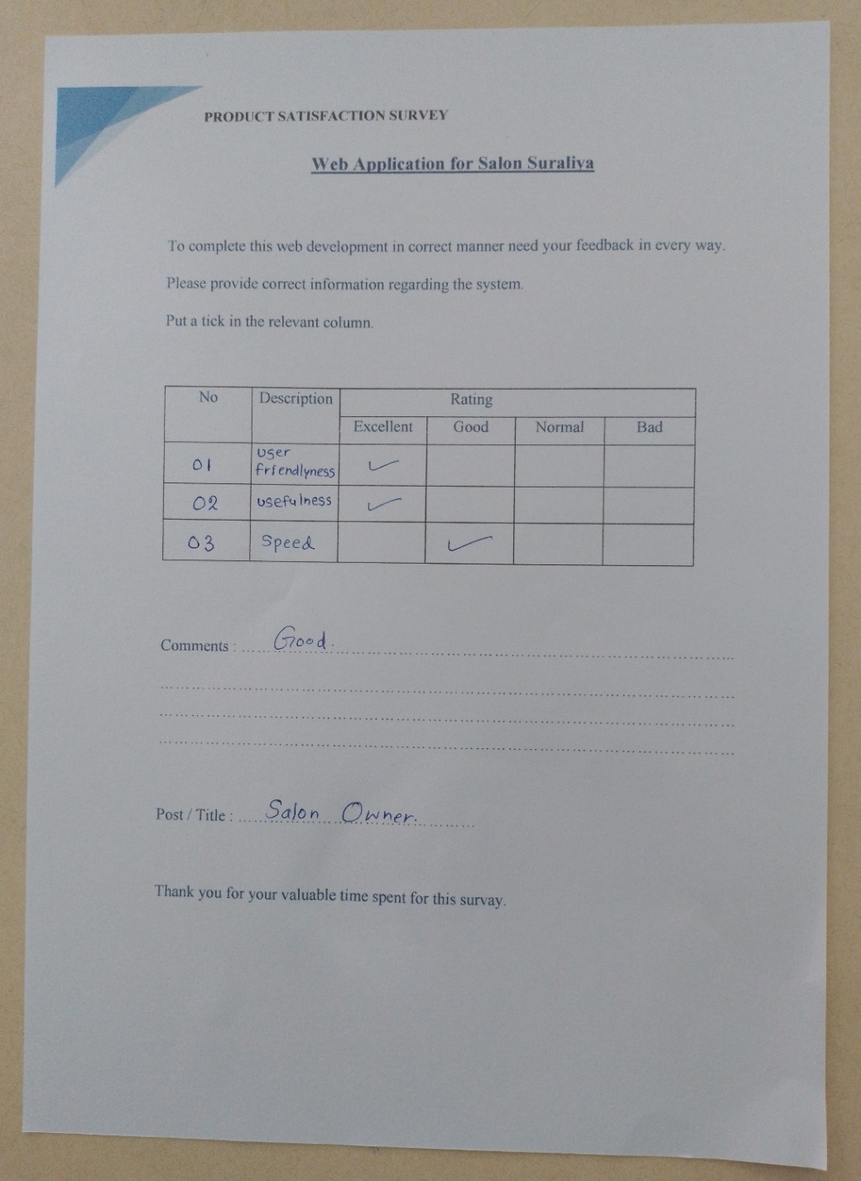Figure 2: illustrates the product satisfaction survey form filled by salon owner. Along with other salon employees feedback for the survey analyzed for final summary product satisfaction.

***Figure 2: Product Satisfaction Survey by Salon Owner***

Figure 3: illustrates the product satisfaction survey form filled by beautician. Along with other salon employees feedback for the survey analyzed for final summary product satisfaction.

11

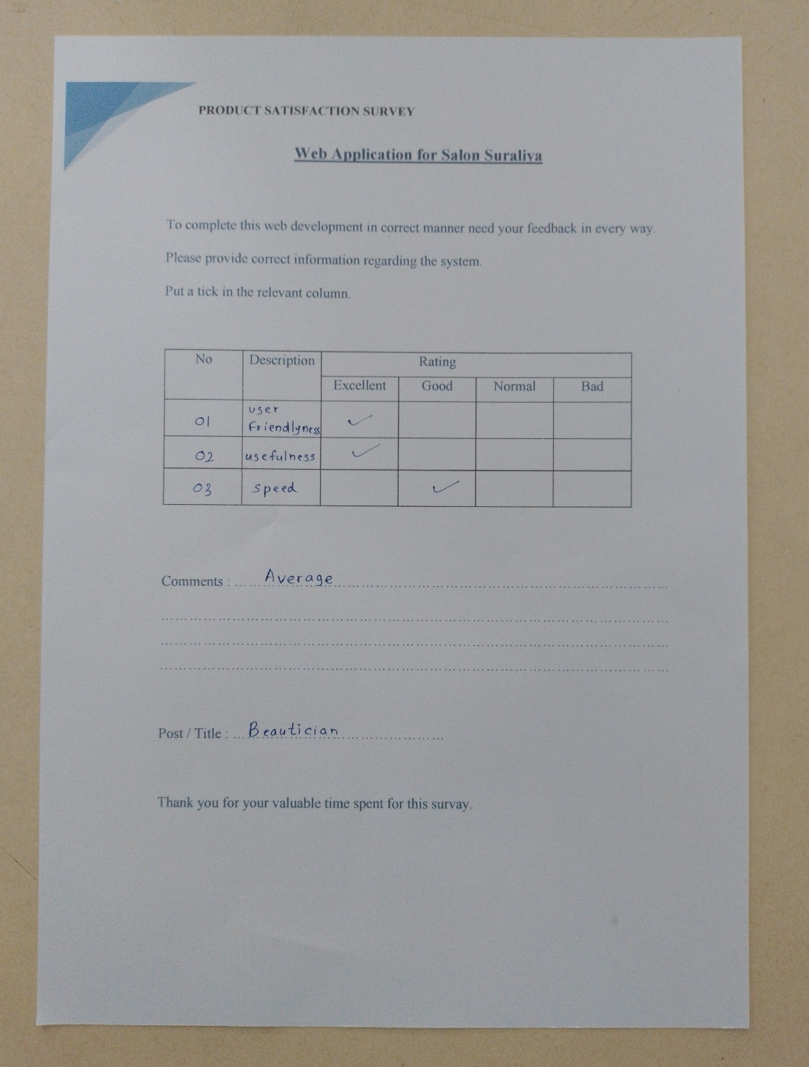

***Figure 3: Product Satisfaction Survey by Beautician***

Overall satisfaction of SBP staff about the new system is good and Figure 5.11 illustrate the chart for the summary of all the staff answered for the satisfaction survey form.

12

***Figure 4: Summary of Product Satisfaction Survey***

**2.6. Implementation Plan**

Once the system was tested, the implementation phase started. A crucial phase in the system development life cycle is successful implementation of new system design. Implementations simply mean converting new system design into operation. This is the moment of truth the first question that strikes in every one's mind that whether the system will be able to give all the desires results as expected from system. The implementation phase is concerned with user training and file conversion.

The term implementation has different meanings, ranging from the conversion of a basic application to a complete replacement of computer system Implementation is used here to mean the process of converting a new or revised system design into an operational one. Conversion is one aspect of implementation. The other aspects are the post implementation review and software maintenance.

13

So, we are planning to deploy our software products under few stages.

• **Pilot Program –** Prior to full-scale installation, pre-test the software with a test group within the company

• **Installation –** The manager should work with the vendor to install the application across all target machines

• **Monitoring, Maintenance, and Follow-Up –** Throughout the implementation process, monitor user feedback, usage data

14

**CHAPTER 3: ANALYSIS**

**3.1. Introduction**

This section will cover the process of discovering, analyzing, defining, and documenting the requirements that are related to the business.

Requirements analysis in systems engineering and software engineering, encompasses those tasks that go into determining the needs or conditions to meet for a new or altered product, taking account of the possibly conflicting requirements of the various stakeholders, analyzing, documenting, validating and managing software or system requirements.

The following objectives were the guide to make a good system analysis:

I. Identify the customer’s need.

II. Evaluate the feasibility of the system.

III. Do both the economic analysis and the technical analysis.

IV. Identify the hardware and software providers.

V. Identify and clearly state the time constraints.

The following diagrams also help a lot in analyzing the system as mentioned above. This chapter will help to do that. These are the some diagrams that we used.

• DFD diagrams

• UML diagrams

• ER diagrams

15

**3.2. DFD Diagrams**

**3.2.1. Context Level Diagram of Proposed System**

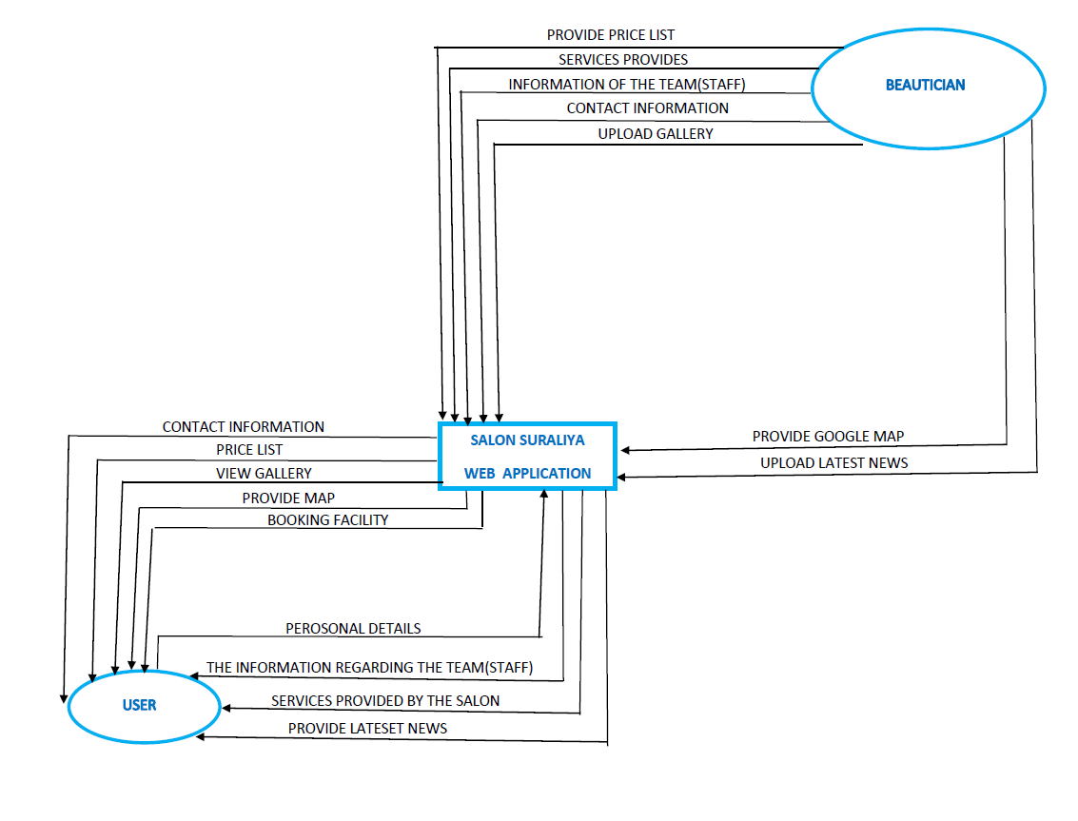

***Figure 5: Context level diagram of proposed system***

16

**3.2.2. Level 0 DFD Diagram of Proposed System**

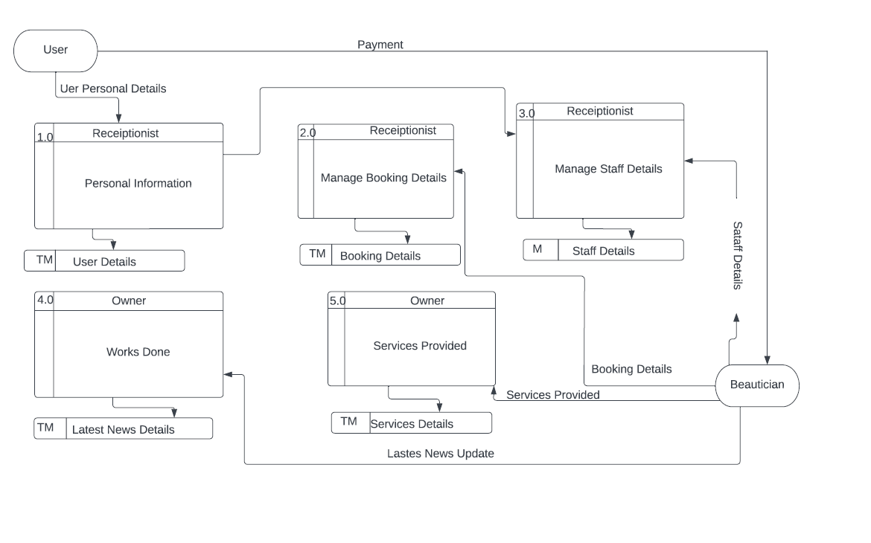

***Figure 6: Level 0 DFD diagram of proposed system***

17

* + 1. **Level 1 DFD Diagram of Proposed System**

**3.2.3.1. Level 1 DFD Diagram for 1.0 Process (Booking Schedule)**

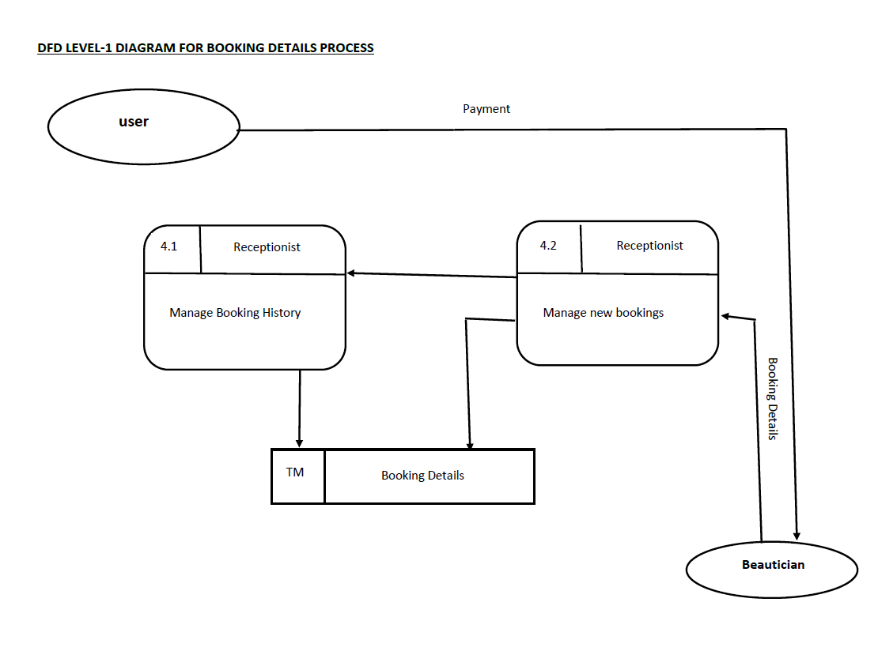

***Figure 7: Level 1 DFD Diagram for 1.0 Process (Booking Schedule)***

18

**3.2.3.2. Level 1 DFD Diagram for 1.0 Process (Staff Details)**

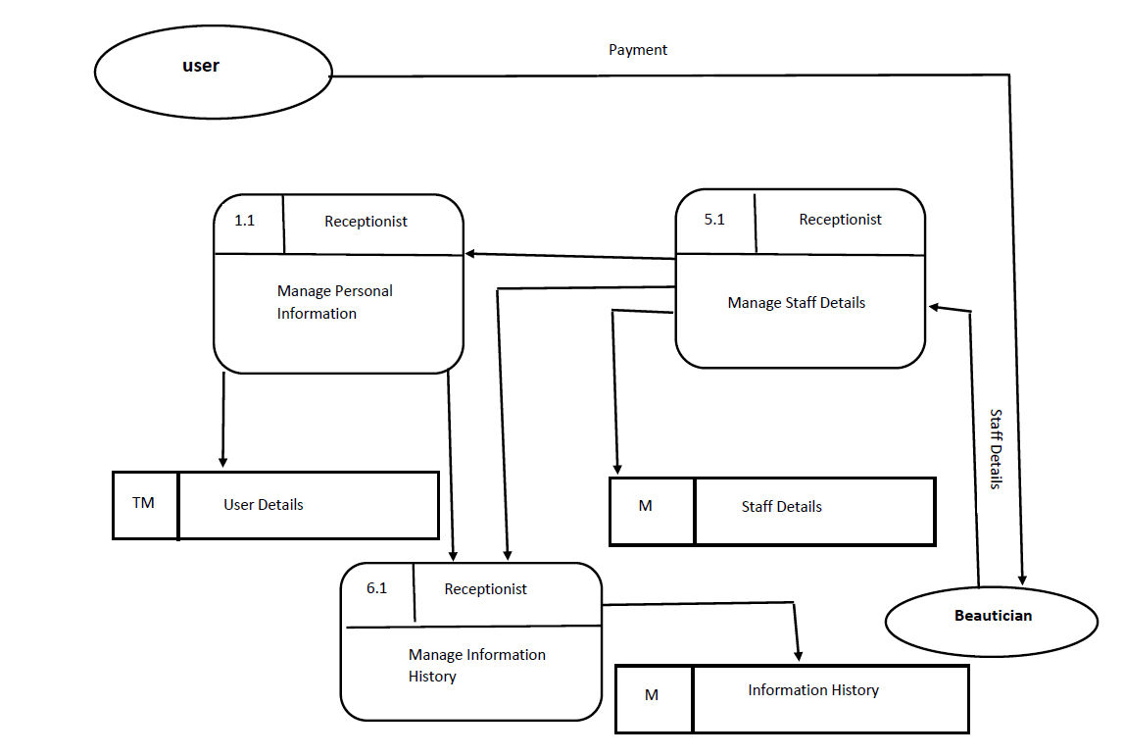

***Figure 8: Level 1 DFD Diagram for 1.0 Process (Staff Details)***

19

**3.2.3.3. Level 1 DFD Diagram for 1.0 Process (Services Details)**

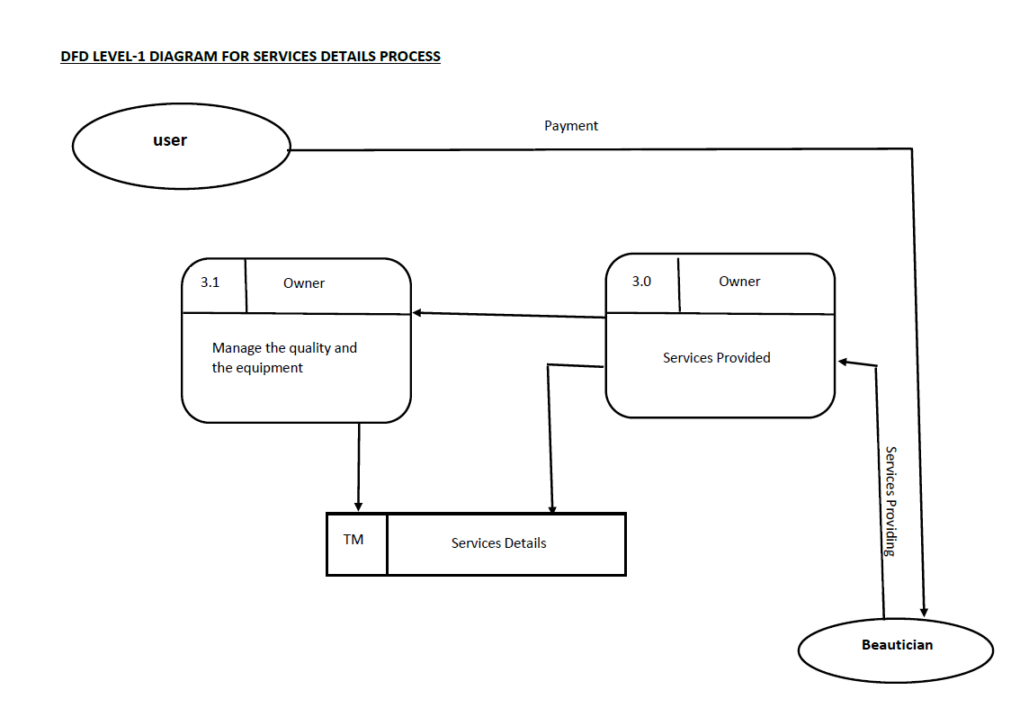

***Figure 9: Level 1 DFD Diagram for 1.0 Process (Services Details)***

20

**3.2.3.4. Level 1 DFD Diagram for 1.0 Process (Latest News Details)**

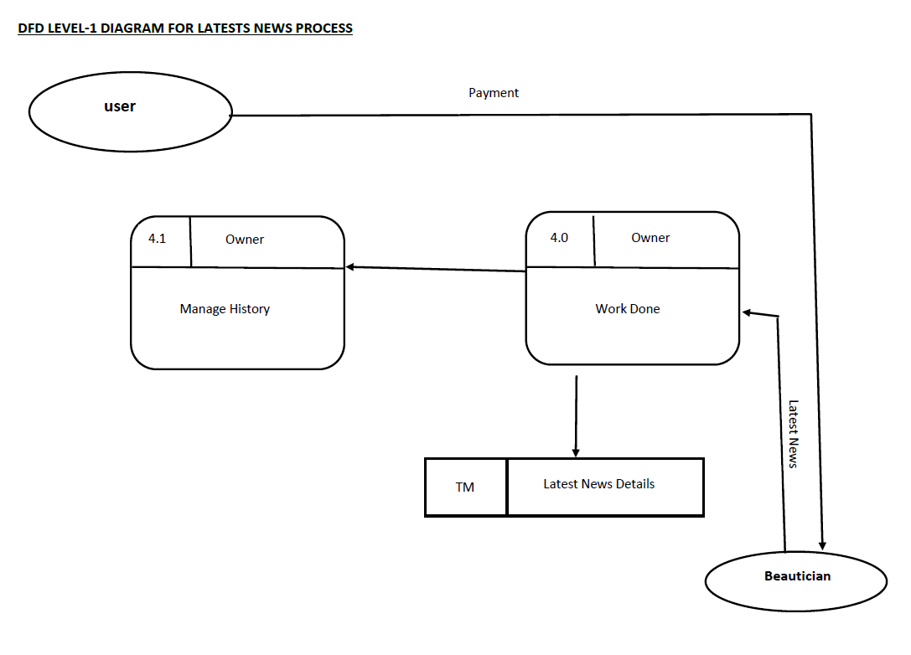

***Figure 10: Level 1 DFD Diagram for 1.0 Process (Latest News Details)***

21

* 1. **UML Diagrams**

**3.3.1. Use Case Diagram of Proposed System**

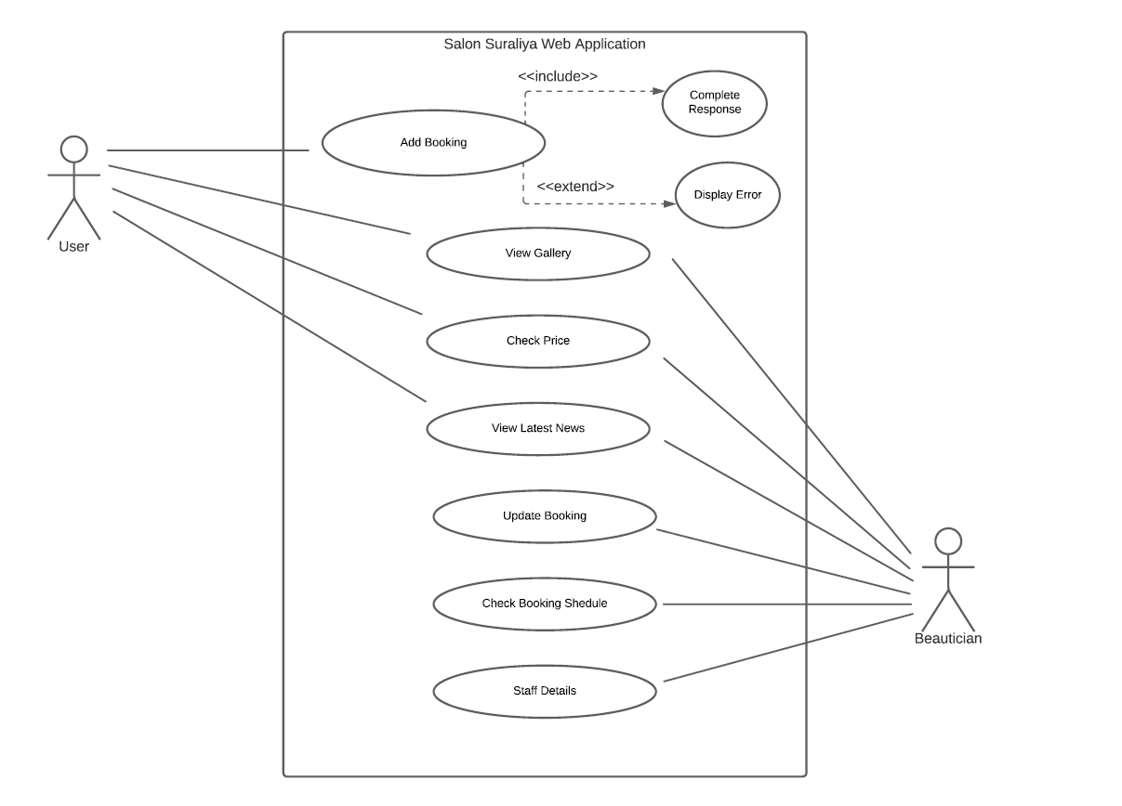

***Figure 11: Use Case Diagram***

22

**3.3.2. Class Diagram of Proposed System**

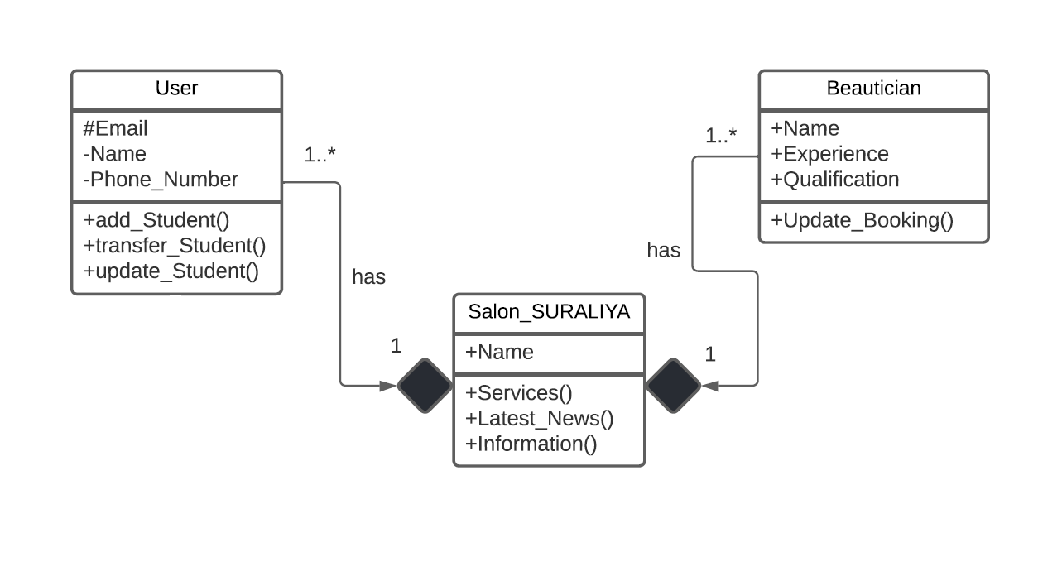

***Figure 12: Class Diagram***

23

**3.4. ER Diagram of the Proposed System**

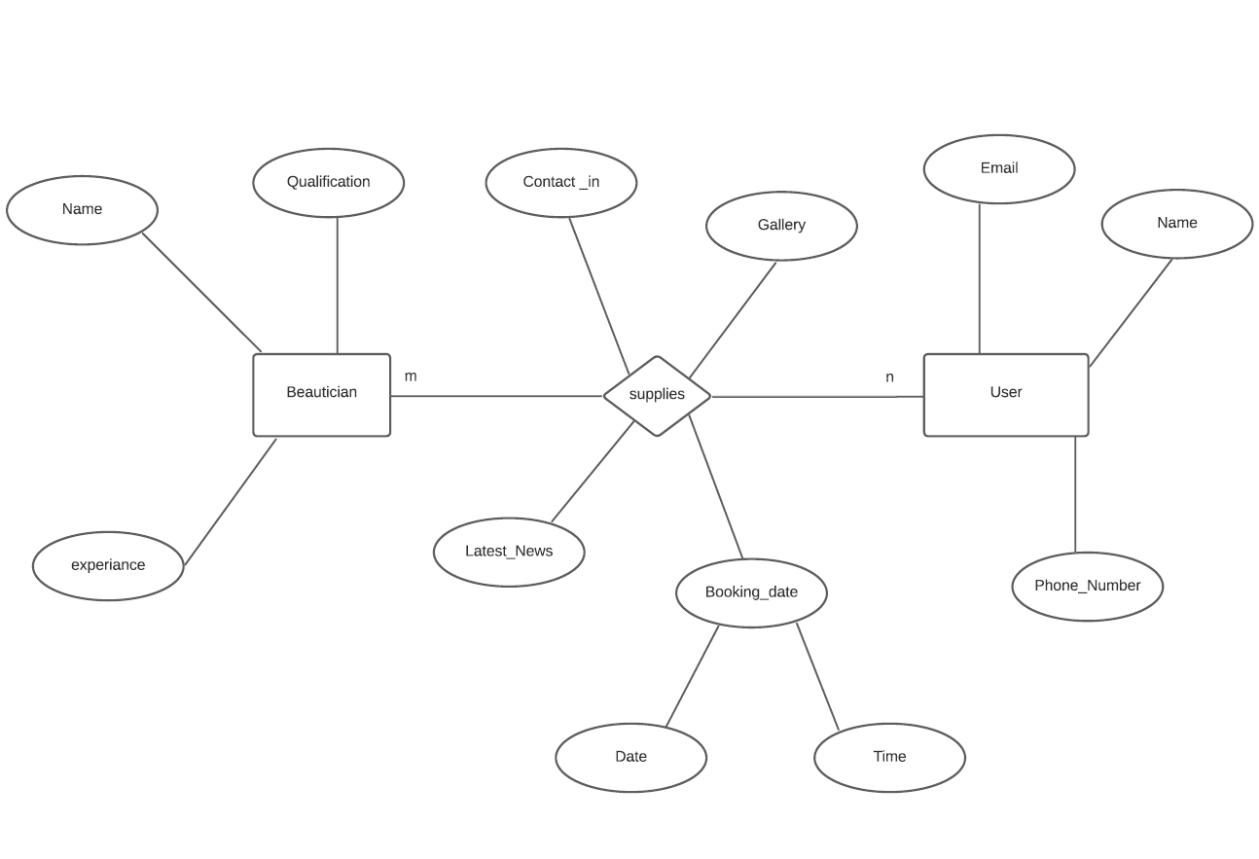

***Figure 13: ER Diagram***

24

**Functional Requirements**

* The system support reservations by consumers and can change them.
* Customers can withdraw their reservations.
* Staff can change information on the reservation of clients (updating check-in, check out and also cancelling booking).
* Customers may post and rate reviews of services.
* Feedback can be sent by customers or a reservation call for the firm.
* Ultimate offer or discount may be verified by customers.

**Non-Functional Requirements**

* Multiple transactions must be handled at a time by the system.
* Customers should offer online reservation service for 24*7 hours.
* Nearly all browsers are supported by the system (Internet Explorer, Safari, Chrome, and Firefox).
* Customers must cancel their reservation prior to 24 hours; else they will have to charge their credit card for one day.

**3.5.Chapter Summery**

Systems are created to solve problems. One can think of the systems approach as an organized way of dealing with a problem. In this dynamic world, the System Analysis and Design (SAD), mainly deals with the software development activities.

In this session, described about how to get idea about currently did that works, how the system was analyzed etc...

25

**CHAPTER 4: SOLUTION DESIGN**

**4.1. Introduction**

Design is also a very important part in the project. Design data base and design user interfaces done in this phase. According to the IEEE definition, design is both “the process of defining the architecture, components, interfaces, and other characteristics of a system or component” and “the result of [that] process”

**4.2. Interface Design**

|  |  |  |
| --- | --- | --- |
| **Screen ID** | **Screen Name** | **Description** |
| S01 | HOME page | Connect all the web pages. |
| S02 | ABOUT page | Provide details about salon. |
| S03 | SERVICES page | Provide details about services. |
| S04 | GALLERY page | Display some works done. |
| S05 | CONTACT page | Provide Contact details. |
| S06 | BOOK NOW page | Provide Booking details. |

***Table 2: Interface design***

26

**Screen ID: S01**

**Screen Name: Home Screen**

**Description: Connect all the web pages.**

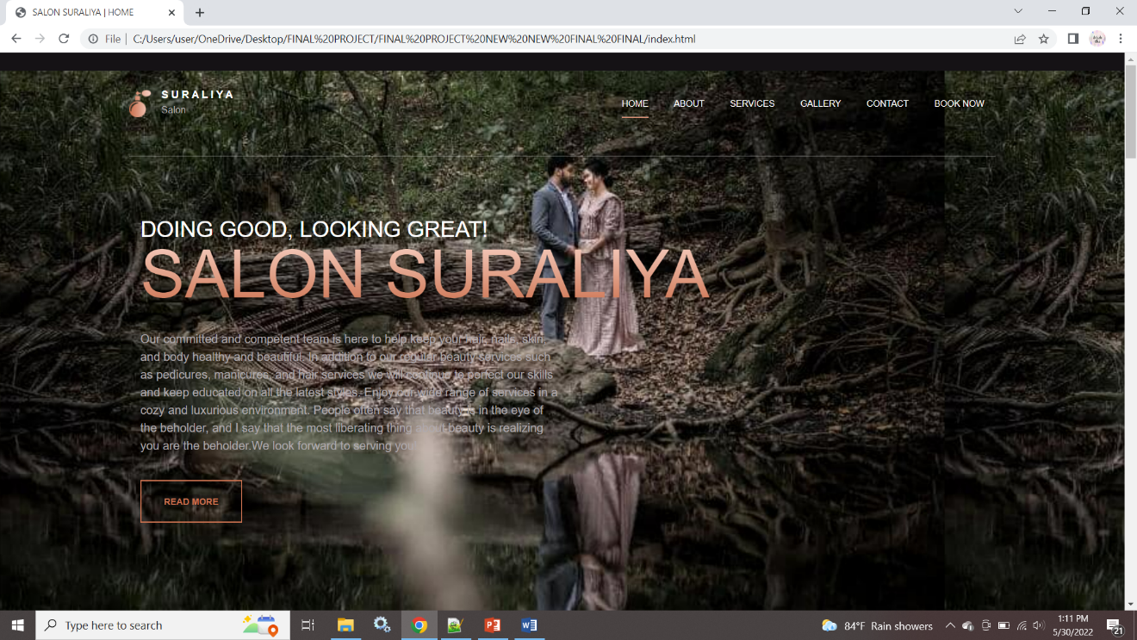

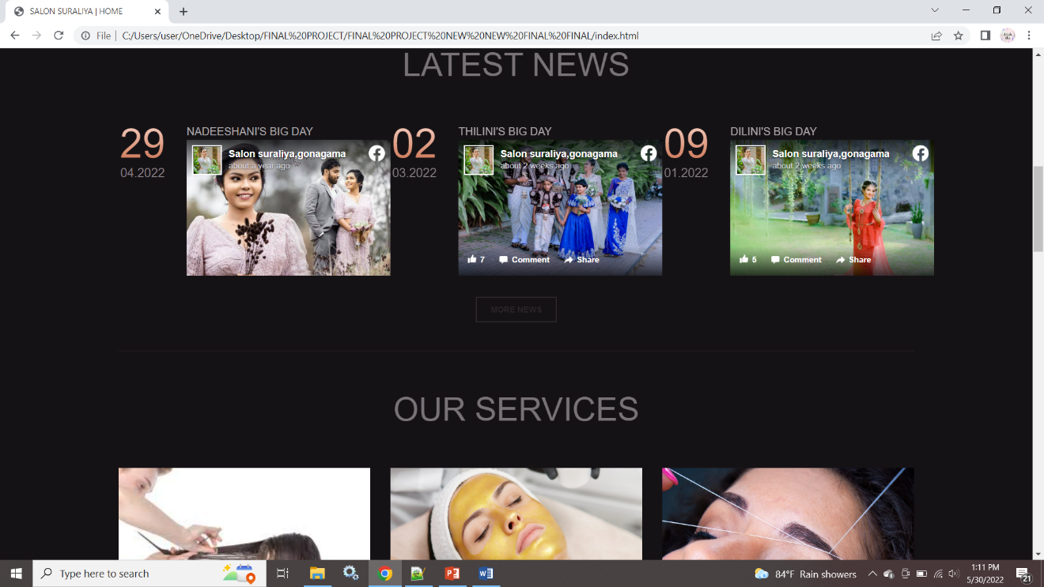

27

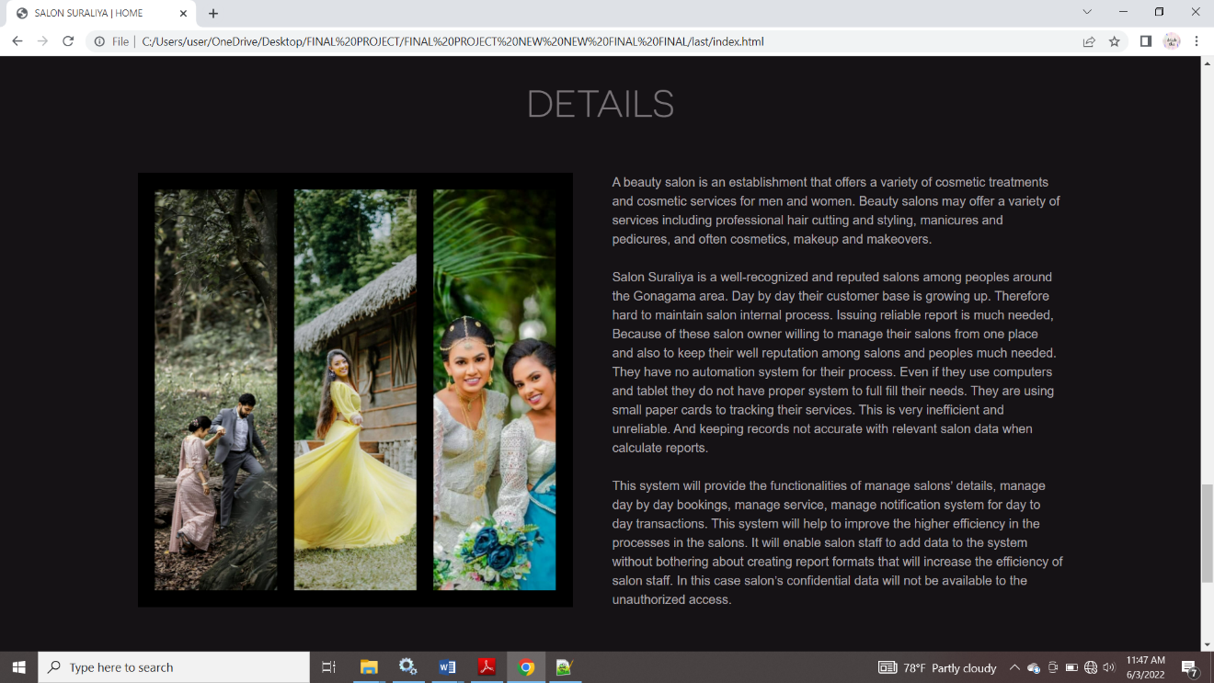

28

**Screen ID: S02**

**Screen Name: About Screen**

**Description: Provide details about salon.**

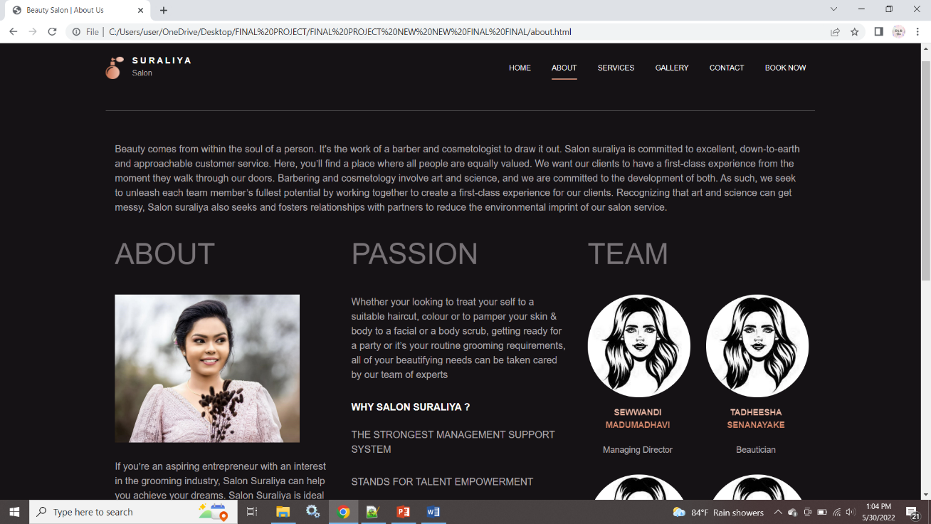

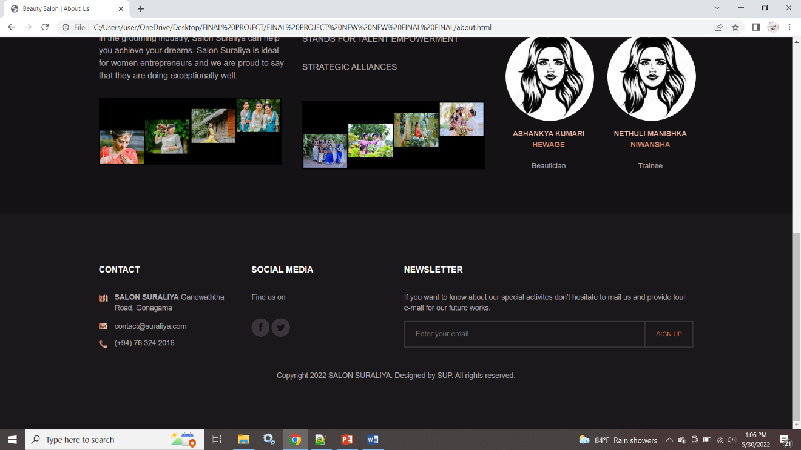

29

vii

**Screen ID: S03**

**Screen Name: Services Screen**

**Description: Provide details about services.**

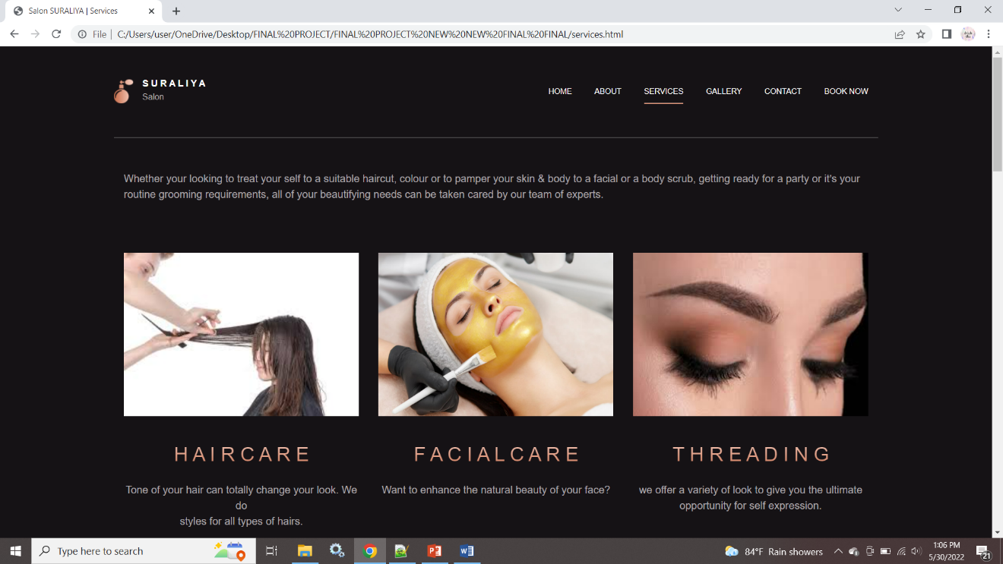

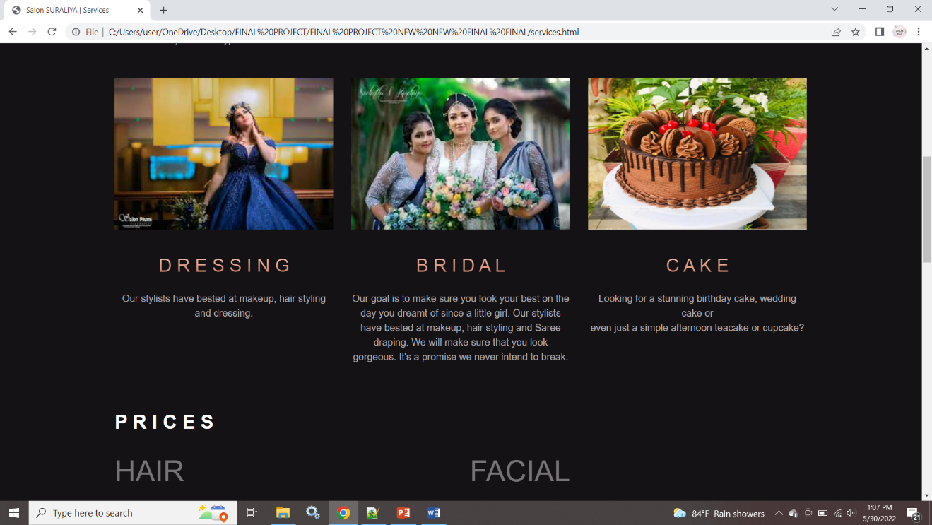

29

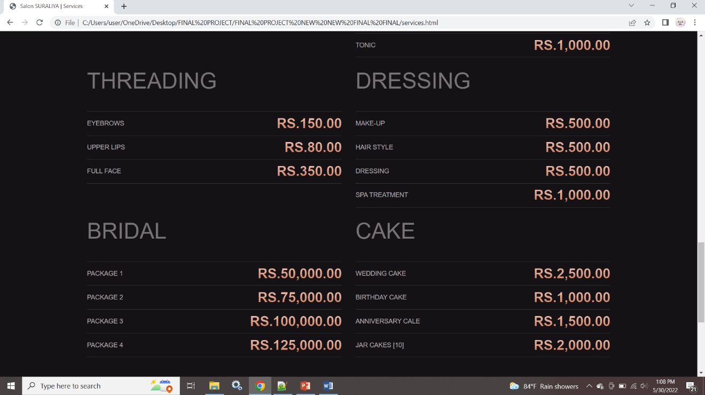

30

**Screen ID: S04**

**Screen Name: Gallery Screen**

**Description: Display some works done.**

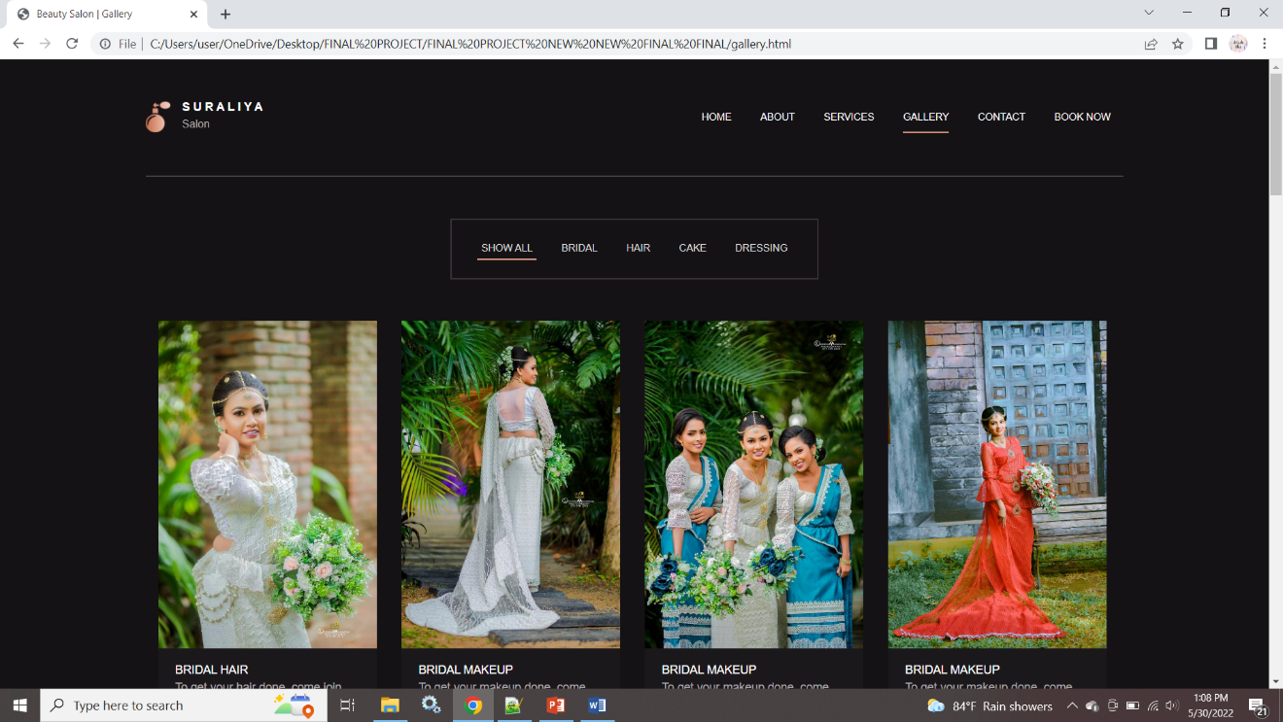

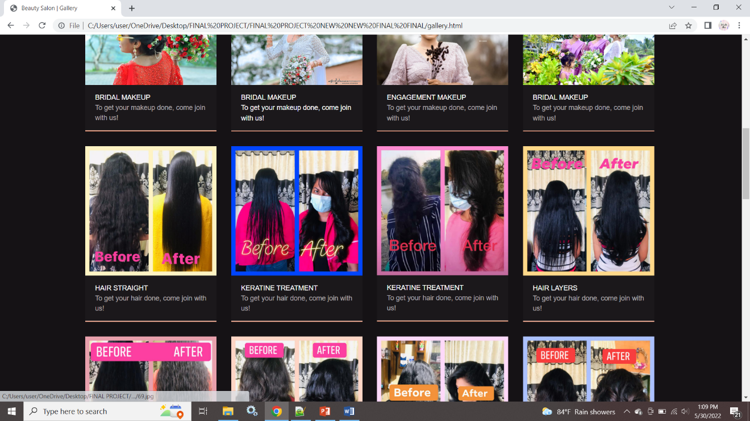

31

**Screen ID: S05**

**Screen Name: Contact Screen**

**Description: Provide Contact details.**

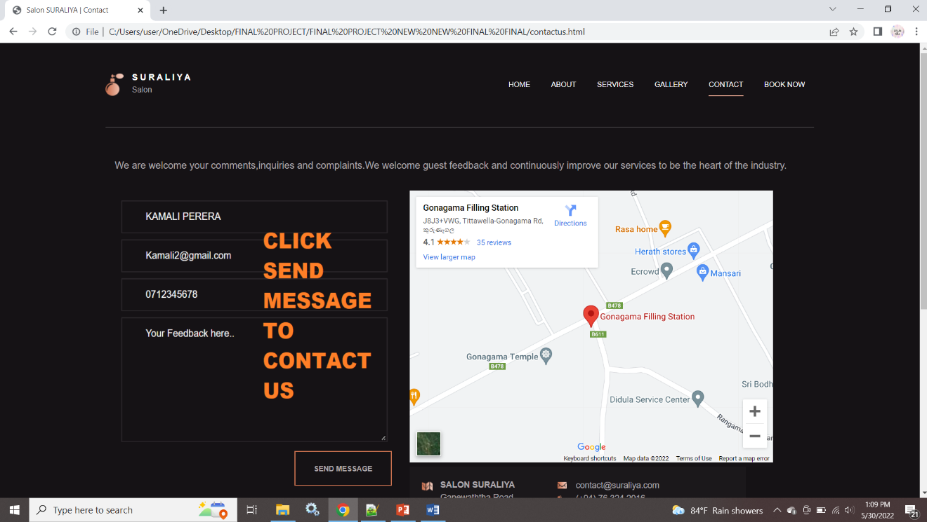

32

**Screen ID: S06**

**Screen Name: Book Now Screen**

**Description: Provide Booking details.**

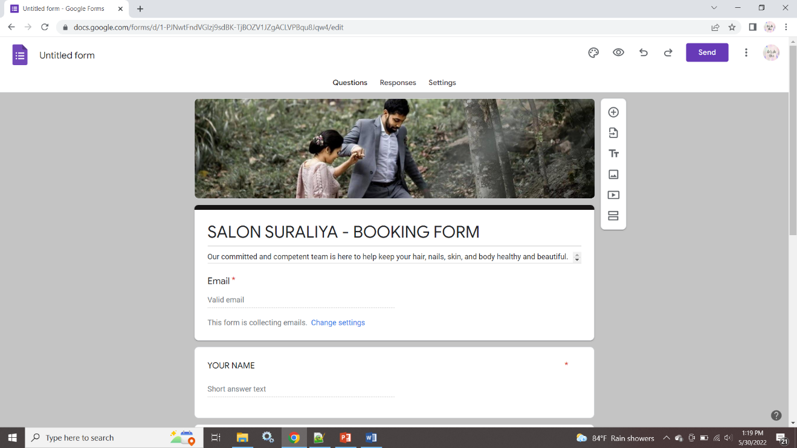

33

**CHAPTER 5: CONCLUSION**

Before the system developed in to business environment it must test in various ways to ensure system not gain any type of error. System testing is performed on the entire system in the context of a Functional Requirement Specification(s) and/or a System Requirement Specification. System testing tests not only the design, but also the behavior and even the believed expectations of the customer. It is also intended to test up to and beyond the bounds defined in the software/hardware requirements specification.

These tests were helped to check,

* The functions developed are according to the specification.
* The identification and reporting of error that occur in the system and correcting them as needed.
* Improving the performance and efficiency of the system.

The system has been factored into different modules to make system adapt to the further changes. Every effort has been made to cover all user requirements and make it user friendly.

* + - **Goal achieved:** The System is able provide the interface to the owner so that he can replicate his desired data.
    - **User friendliness:** Though the most part of the system is supposed to act in the background, efforts have been made to make the foreground interaction with user (owner) as smooth as possible. Also the integration of the existing system with the project has been kept in mind throughout the development phase.

**REFERENCES**

* W3schools - <https://www.w3schools.com/cs/index.php>
* Tutorials point - <https://www.tutorialspoint.com/jdbc/jdbc-insert-records.htm>
* GeeksforGeeks - <https://www.geeksforgeeks.org/html/>
* Stack Overflow - <https://stackoverflow.com/>
* Naturals Salon - <https://www.naturals.lk/>
* YouTube - <https://www.youtube.com/>

34

**Appendices**

**13.1. The project Schedule**

|  |  |  |  |  |  |  |  |  |  |  |  |  |  |  |  |  |
| --- | --- | --- | --- | --- | --- | --- | --- | --- | --- | --- | --- | --- | --- | --- | --- | --- |
| **Week**  **Task** | **1** | **2** | **3** | **4** | **5** | **6** | **7** | **8** | **9** | **10** | **11** | **12** | **13** | **14** | **15** | **16** |
| Project Proposal submission and approval |  |  |  |  |  |  |  |  |  |  |  |  |  |  |  |  |
| Analysis Stage |  |  |  |  |  |  |  |  |  |  |  |  |  |  |  |  |
| Design Stage |  |  |  |  |  |  |  |  |  |  |  |  |  |  |  |  |
| Implementation Stage |  |  |  |  |  |  |  |  |  |  |  |  |  |  |  |  |

***Table 3: Project timeline***

35

**13.2. Letter Issued by the organization**

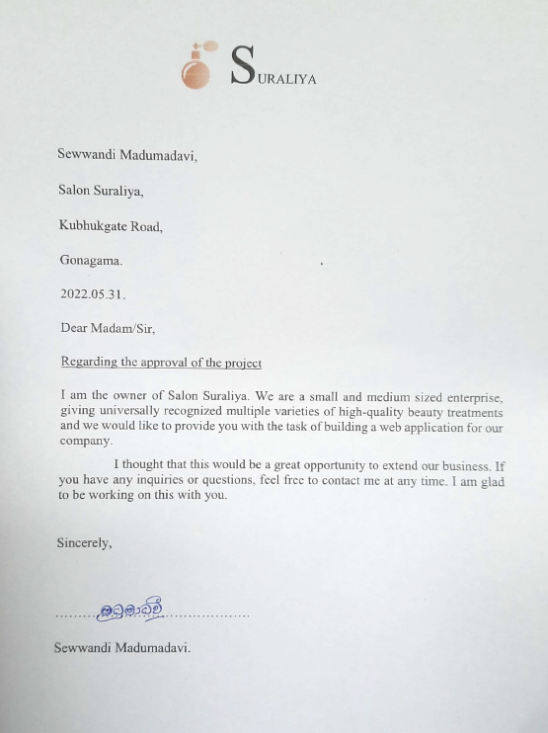

***Figure 14: Letter Issued by the organization***

36

**Questioners and Interview Questions**

These are the questioners and interview questions when we used to create to our web application.

❖ **Question 01:** Why do you need this system?

**……………………………………………………………………………………………………………………………………………………………………**

❖ **Question 02:** Do your organization had a management system earlier?

**……………………………………………………………………………………………………………………………………………………………………**

❖ **Question 03:** What are the major roles in your organization?

**……………………………………………………………………………………………………………………………………………………………………**

❖ **Question 04:** What is the role of a beautician you want to add inside the system? **……………………………………………………………………………………………………………………………………………………………………**

❖ **Question 05:** Then, who manages other roles such as staff details?

**……………………………………………………………………………………………………………………………………………………………………**

❖ **Question 06:** Please tell me about the activities that you need to put in the system?

**……………………………………………………………………………………………………………………………………………………………………**

37

❖ **Question 07:** What information do you get when you entered to the system? **……………………………………………………………………………………………………………………………………………………………………**

❖ **Question 08:** What information do you get when you subscribe the news letter? **……………………………………………………………………………………………………………………………………………………………………**

❖ **Question 09:** What packages are in your organization? **……………………………………………………………………………………………………………………………………………………………………**

❖ **Question 10:** how do you schedule appointments? **……………………………………………………………………………………………………………………………………………………………………**

38

These are the answers of above questioners and interview questions when we used to create the Bull Fitness Software Application.

❖ **Question 01:** Why do you need this system?

**Answer:** Because it helps you to make better-informed decisions and it easy our works.

❖ **Question 02:** Do your organization had a management system earlier?

**Answer:** No, we used manual papers to store our records.

❖ **Question 03:** What are the major roles in your organization?

**Answer:** Trainer, Member, Admin or Owner

❖ **Question 04:** What is the role of a beautician you want to add inside the system

**Answer:** He can only manage the member details and member fees.

❖ **Question 05:** Then, who manages other roles such as staff details??

**Answer:** Admin or owner (both the same person) he should be able to run the whole system.

❖ **Question 06:** Please tell me about the activities that you need to put in the system?

**Answer:**

* Add, delete, update and view members with their details. (It only can handle for trainers and admin)
* Add, delete, update and view trainers with their details. (It only can handle for admin)
* Calculate trainer salary for their works and it can handle only the admin (owner) in the system

39

* Can handle member payment and issue a receipt for it. (It only can handle for admin)

❖ **Question 08:** What information do you get when you subscribe the news letter?

**Answer:** The following things are we get when the new member register.

o Name

o NIC

❖ **Question 09:** What packages are in your organization?

**Answer:** The following things are we get when the new trainer register.

o Name

o NIC

o Email

o Mobile number

o Address

o Gender

o Position

o Date of joined

❖ **Question 10:** how do you schedule appointments?

**Answer:** Using Booking Form

40

**Reviewed Documents**

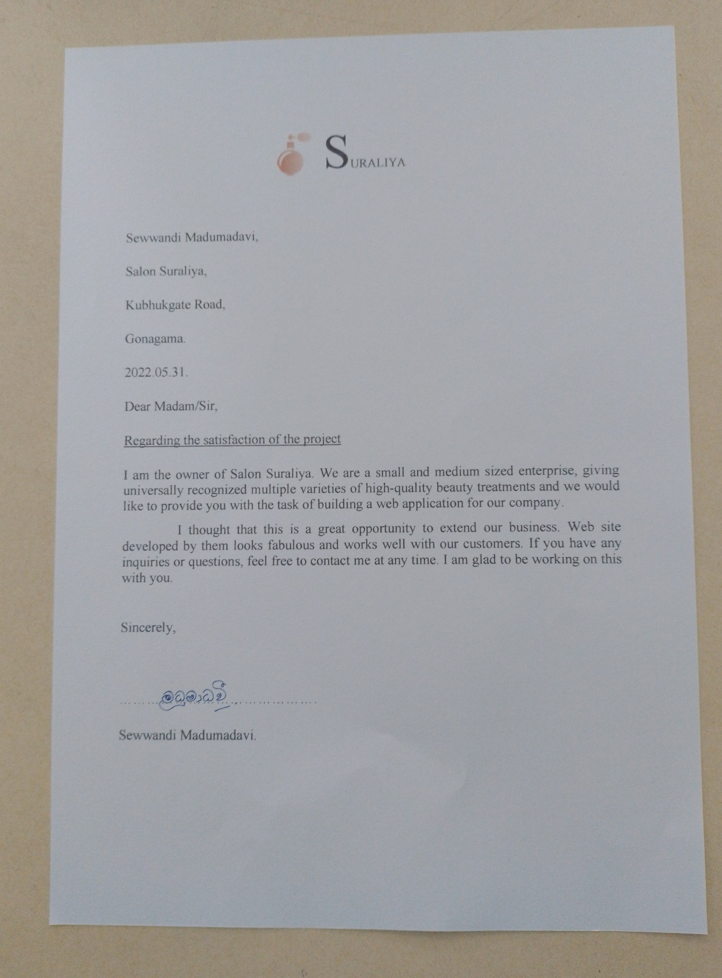

***Figure 14: Letter Issued by the organization for satisfaction***

41

**USER MANUAL DOCUMENTATION**

**CHAPTER 01 | INTRODUCTION**

**1.1. About the User Guide**

The purpose of this user guide is to educate the users of this system as to how they should utilize it to get their work done.

The usage of all available options within the system has been described in details thought this document. This will take you from the installation of the system and how to co work with processes, how to use the system for each type of users, and finally uninstall the system.

**CHAPTER 2 | HOW TO INSTALL THE SYSTEM**

**2.1. Minimum Requirements**

* PC`s or Laptops having this or higher specifications.
* Intel Dual Core CPU 1.8 GHz
* 3GB Ram
* 160GB Hard Drive
* Support USB 2.0
* CD-ROM Drive
* Network Connection (Router) ADSL or Wireless 4G

42

**2.2. Installation**

**Before install**

To ensure a successful installation you should complete the following task, which are describe in the section that follow before you install the software.

* Make sure your hardware components meet the minimum requirements and all the equipment is properly configured.
* Make sure Network is properly configured and in working condition.
* Obtain system (this software) compatible software and hardware.

**What is in the CD?**

The CD contains the zip folder, reports , letters folders and Read Me files. The Source code can be used for further developments.

You need to unzip and place the folder where you want in the computer.

**2.3. How to install the System using CD-ROM**

**Step 01 -** Insert the given CD to the CD-ROM.

**Step 02 –** find zip file on your computer.

**Step 03 -** unzip the zip folder.

**Step 04 -** place the folder where you want in the computer.

43

**CHAPTER 3: OPERATIONS & FUNCTIONS**

**3.1. HOME page**

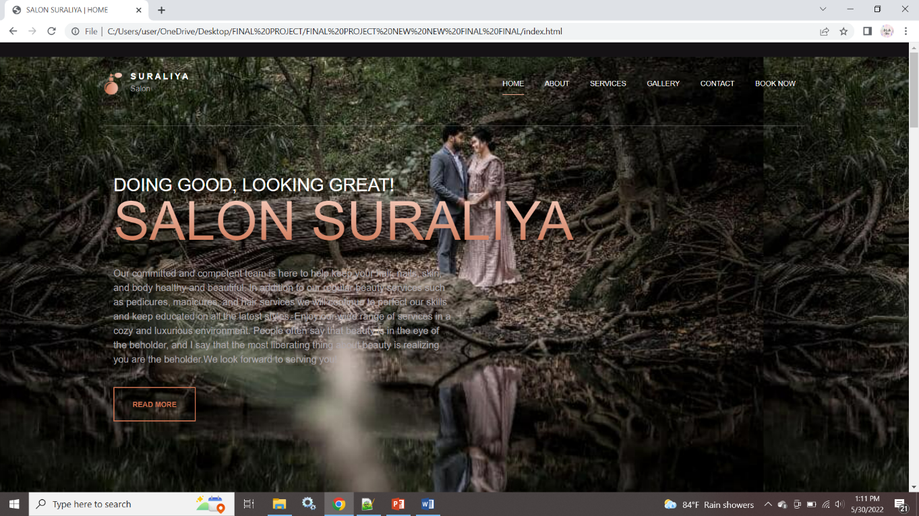

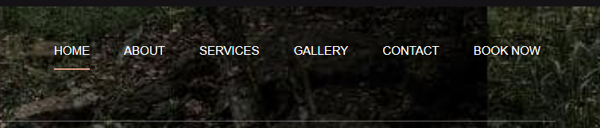

**A B C D E F**

**A –** Click “HOME” to view Home Page.

**B –** Click “ABOUT” to view About Page.

**C –** Click “SERVICES” to view Services Page.

**D –** Click “GALLERY” to view Gallery Page.

**E –** Click “CONTACT” to view Contact Page.

**F -** Click “BOOK NOW” to view Book Now Page.

44

**Provide Latest News**





45

**3.2. ABOUT page**

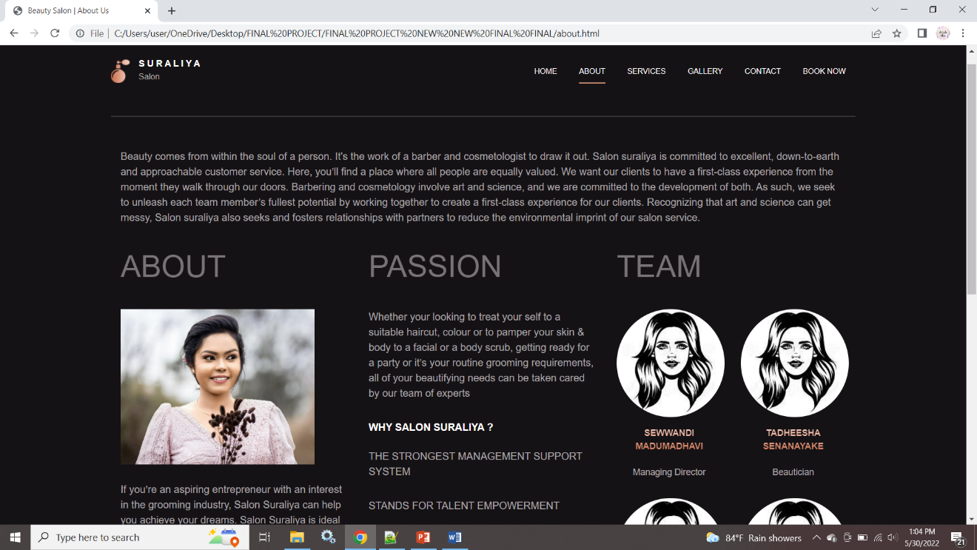

* **Provide some information about Salon Suraliya**



46

**3.3. SERVICES page**



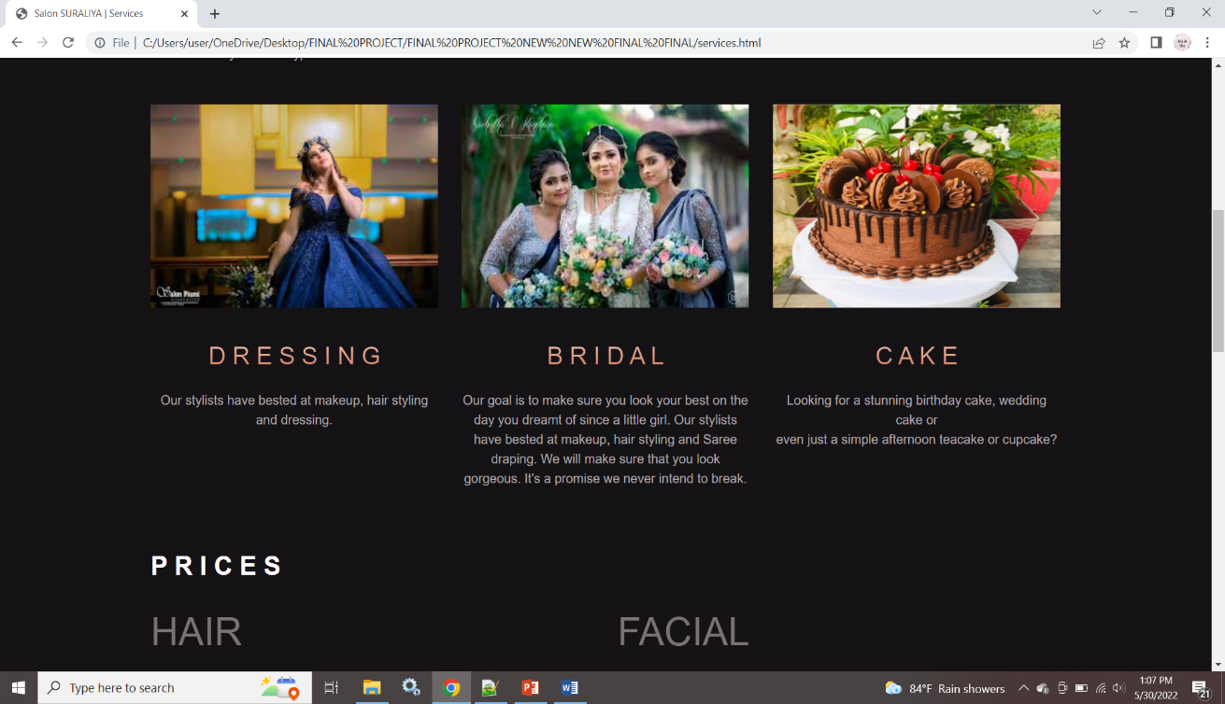

* **Display the Services done by Salon Suraliya**

47



* **Display the Price List**

48

* 1. **GALLERY page**



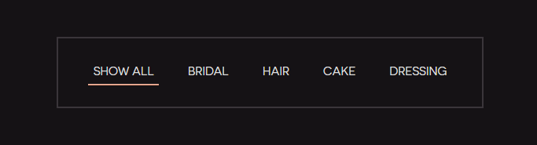

**A B C D E**

**A –** Click “SHOW ALL” to view all the photos.

**B –** Click “BRIDAL” to view bridal photos.

**C –** Click “HAIR” to view photos of hair done.

**D –** Click “CAKE” to view photos of cake.

**E –** Click “DRESSSING” to view Dressing photos.

49



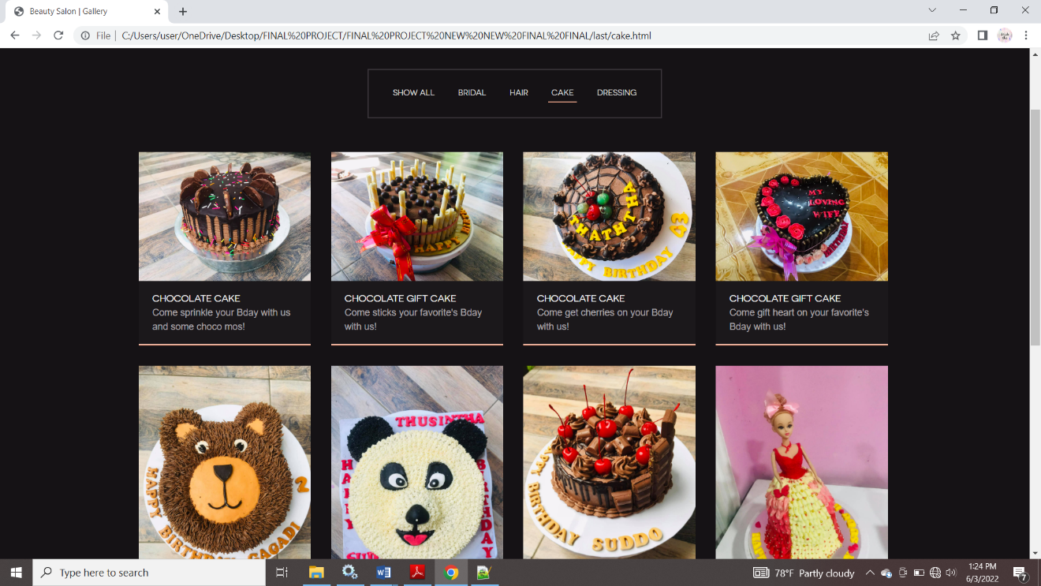

50

* 1. **CONTACT page**



* **By clicking send message button we can view contact form.**
* **From the Google Map we can view the location of the Salon.**

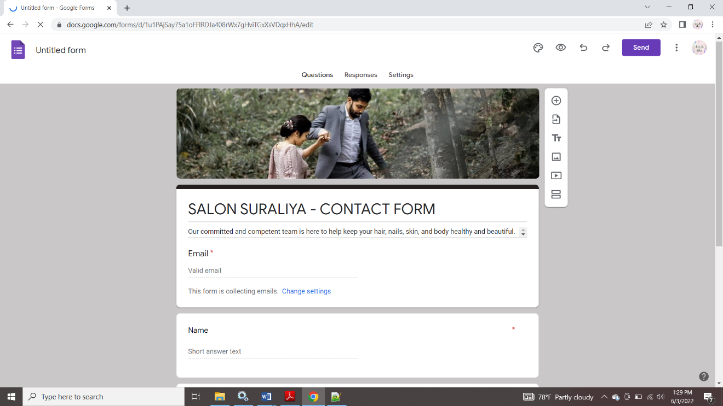

51

* 1. **BOOK NOW page**



* **User can make appointments using booking form.**

52